The Suez Canal and the British Conquest of Egypt and Sudan
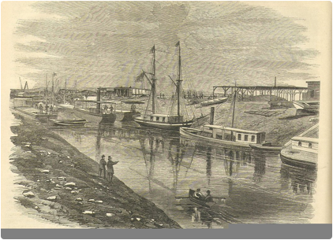
One clear signal for the start of the Scramble for Africa was the British takeover of Egypt in 1882. The imperial land grab began with the world’s most amazing engineering feat at the time, a 102-mile-canal that connected the Mediterranean Sea with the Indian Ocean through the Isthmus of Suez in Egypt. The sea level waterway would allow for much quicker travel from Europe to Asia because boats would no longer need to sail thousands of miles around Africa. The French Suez Canal Company started the project in 1859 and completed it in 1869—the same year the United States finished the transcontinental railroad (Brendon 146-7). Both of these projects showed how travel time around and through continents shrank drastically in the later industrial age. This time-space compression increased access to markets, raw materials, and cheap labour around the world.
The French designed and managed the Suez Canal project with European capital and Egyptian labour. A Frenchman, Ferdinand De Lesseps, made a favourable agreement with the Khedive of Egypt, Said Pasha, to build the canal and operate it for 99 years. The Khedive, hoping the scheme would modernise Egypt, invested money, supplied the labour, and gave up agricultural land on either side of the canal (Pakenham 77). The Khedive thought the canal brought Egypt closer to the West. “We are not now a country of Africa, but a country of Europe” (Pakenham 75). Over one million Egyptians worked on it, many as forced labourers, and thousands died. The project called for the removal of 100 million cubic feet of sand and dirt and cost twice the original estimate. The Egyptian leader had gone into deeper and deeper debt—with the help of extortionist interest rates owed to European banks—trying to modernise Egypt with costly railroads, harbours, schools, and irrigation projects. The British had been at first sceptical of the viability of the canal project. But once it proved successful, the British government jumped at the chance to buy the Egyptian ruler’s shares in 1875 when he needed cash (Brendon 147).
An economic and political crisis between 1875-1882 led to the sudden British conquest of Egypt. After binging on debt driven modernisation projects, Egypt went bankrupt in 1875 (Sayyid-Marsot 653). As the terms of the bankruptcy settlement, European bankers then took control of Egypt financially. Two thirds of the yearly revenue—mostly taxes collected from peasant farmers—would now go to paying European banks for past Egyptian debts (Sayyid-Marsot 653). The British and French controlled all Egyptian finances, railways, ports, post offices, and even the museums (James 269). Some Egyptians resented the European control of their economy and the extortion interest rates of the loans.
In 1882, the British invaded and conquered Egypt to put down a revolt of Egyptian army officers. Colonel Urabi of the Egyptian army—with support from disgruntled officers—overthrew the Khedive. Urabi dressed and looked like Arab peasants who called him “el Wahid,” meaning “the only one”, (Pakenham 125). The British, of course, were worried about the Suez Canal falling into the hands of an unfriendly power. When the British sent the navy to bombard Alexandria from the sea, Egyptian mobs rampaged and killed 50 Europeans (Pakenham 132). With the Khedive’s support, the British attacked both ends of the Suez Canal, sailed to the midpoint, and rushed to Cairo, using a new railroad to transport supplies (Sayyid-Marsot 654). Urabi surrendered. The British had an army of 31,000 while Urabi had only 16,000 poorly trained troops with old rifles and swords (UNESCO 37 and James 272). Britain now held Egypt as a virtual colony, which also gave them responsibility for territory Egypt had controlled in the south, in Sudan.

Resistance: The Mahdi Uprising in Sudan
Resentful of British and Egyptian intervention, many Sudanese Muslims south of Egypt supported a large uprising for independence. In 1881, a Muslim sheik, Muhammad Ahmad, led a four-year successful military campaign against armies led by Egyptian and British officers. Ahmad proclaimed himself the Mahdi, the “redeemer of the faith”, and won followers by declaring that it was time to revitalise Islam. The Mahdi claimed to descend from the Prophet Muhammad and demanded strict adherence to the words of the Prophet in the Qur’an. This fundamentalist focus on the Qur’an as the spiritually pure way to resist imperialism would echo with similar movements in the Middle East a century later. His attempt to establish an Islamic State ruled by Sharia law foreshadowed 20th century Saudi Arabia, Iran, and Afghanistan. Some Sudanese Muslim scholars, however, were sceptical that Ahmad was the Mahdi, especially after he changed the five pillars of Islam so that followers would include him in their profession of faith: “Muhammad Ahmad is the Mahdi of God and the representative of His Prophet” (Wikipedia). He also omitted the haj to Mecca and substituted it with a new pillar, a jihad against infidels. In any case, Ahmad successfully resisted foreign rule in Sudan and in doing so gained popularity. In 1883, he defeated the last fighting force of the Egyptian army. Since, at the time, the British considered Sudan relatively unimportant, they ordered an evacuation of their sparse troops to Egypt (Wikipedia). One British officer, however, refused to leave.
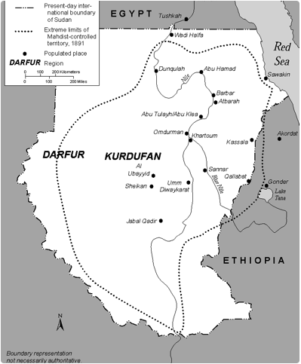
To complete the Sudanese reconquest of Sudan, the Mahdi’s army overwhelmed the last British presence at the Battle of Khartoum. The Egyptian Khedive instructed the British Colonel Charles Gordon to govern the area south of Egypt, push all the way down to Lake Victoria, and stop the slave trade in East Africa. Though the goals were unrealistic, they aligned with Gordon’s “man on the spot” imperialist ambition. He set to work establishing outposts along the Nile all the way to Buganda (Pakenham 81). The British government in London, however, found little use for Sudan and ordered Gordon to evacuate the last British presence in the town of Khartoum, which lay at the strategically important fork of the White and Blue Nile Rivers. Gordon, however, refused the order, unwilling to give up on the imperial project he had started (James 277). The British colonel had 8,000 soldiers but soon found his encampment surrounded by a much larger Mahdi army (Pakenham 221). He then lost his best general and 1,000 of his best soldiers when their Sudanese guide betrayed them by leading them into an ambush (Pakenham 223). Displeased with Gordon’s refusal to evacuate, the British prime minister did not rush to order reinforcements. Khartoum fell in January 1885, just two days before slow moving British relief forces arrived. The Mahdi’s troops killed Colonel Gordon (who had, true to form, refused to surrender), decapitated him, and carved up his body (Pakenham 272). Six months after the Battle of Khartoum, the self-proclaimed Mahdi suddenly died of Typhus, but his successors continued the Islamic state (Pakenham 274). The British evacuated Sudan rather than avenge the martyrdom of Gordon. The imperialists had lost, but they would return 13 years later to conquer Sudan for good.

The Conquest of Sudan
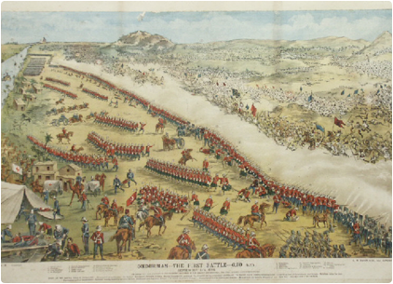
The martyrdom of Colonel Gordon at the Battle of Khartoum took thirteen years to avenge, and during that time industrial weapons became more accurate and deadly. The British conquest of Sudan at the Battle of Omdurman in 1898 was a tragic example of the triumph of modern weapons—long rang rifles, artillery, and the Maxim gun—over traditional means of warfare that had existed for thousands of years. Whereas the Ethiopian Emperor had smartly invested in European weapons and saved his kingdom, the 50,000 Mahdi soldiers had no modern rifles, only spears and swords (Pakenham 538).
The Battle of Omdurman was a complete disaster for the preindustrial Mahdi Army. They attacked the British in broad daylight despite the long range of British rifles, machine guns, and artillery, and lost 2,000 soldiers in just a few minutes during the first attack (Pakenham 544). Still the Mahdi generals kept sending waves of soldiers towards the industrial army. By the end of the battle, the British Army had killed 11,000 Sudanese and had lost only 48 of their own (Boahen 48 and Pakenham 546).
23 year old British soldier Winston Churchill—future First Lord of the Admiralty during World War I and Prime Minister during World War II—described the devastating impact of British artillery at the Battle of Omdurman against a poorly armed infantry charge:
“Did they know what would come to meet them? They were in a dense mass, 2,800 yards from the 32nd Field Battery and the gunboats. The ranges were known. It was a matter of machinery. The more distant slaughter passed unnoticed, as the mind was fascinated by the approaching horror. In a few seconds swift destruction would rush on these brave men. They topped the crest and drew out into full view of the whole army. Their white banners made them conspicuous above all. As they saw the camp of their enemies, they discharged their rifles with a great roar of musketry and quickened their pace. For a moment, the white flags advanced in regular order, and the whole division crossed the crest and were exposed. Forthwith the gunboats, the 32nd Field Battery, and other guns . . . opened on them. About twenty shells struck them in the first minute. Some burst high in the air, others exploding in their faces. Others, again, plunged into the sand and, exploding, dashed clouds of red dust, splinters, and bullets amid their ranks. The white banners toppled over in all directions. Yet they rose again immediately, as other men pressed forward to die for the Mahdi’s sacred cause and in the defence of the successor of the True Prophet. It was a terrible sight, for as yet they had not hurt us at all, and it seemed an unfair advantage to strike thus cruelly when they could not reply . . . Thus ended the battle of Omdurman—the most signal triumph ever gained by the arms of science over barbarians. Within the space of five hours the strongest and best-armed savage army yet arrayed against a modern European Power had been destroyed and dispersed, with hardly any difficulty, comparatively small risk, and insignificant loss to the victors . . .” (Worger, et al 262-264).

